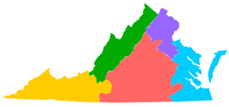VIRGINIA Society of Medical Assistants
2 yr Strategic Plan
2017-2018
Goal I: Mentoring
- Each past officer in the society adopt a member with potential mentor for a committee chair or officer position as they are serving in that particular position.
- Provide mentee with appropriate VSMA (Virginia Society of Medical Assistants) documents, copy with all correspondence relating to that position and provide feedback as to rational for activities.
Goal II: Engage Member Educators
- Seek educators in Virginia to speak on topics at the VSMA annual conference and seminar
- Have educators speak at state meetings.
Goal III: Engage Student Members
- Give student members the chance to participate/volunteer at a VSMA seminar at their respective schools.
- Students may assist in presenting educational topics
Goal IV: Promote the CMA (AAMA) as the preferred credential
- Encourage CMAs (AAMA) to promote the profession of medical assistanting and credential to employers.

