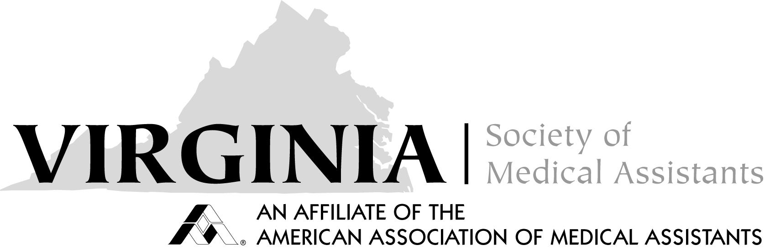
VSMA 3rd Executive Board Meeting
2/18/2018
Online
CALL TO ORDER: 1:05pm
Roll Call by Nina Beaman, EdD, MSN, CMA (AAMA)
Quorum = 5% of board members: YES
APPROVAL OF MINUTES: posted to the website, Motion by Deb Benson, CMA (AAMA), CPC, CPMA, seconded by Tanisha Farissier, CMA (AAMA), motion carried
CORRESPONDENCE: God’s Pit Crew tax statement, BOT February Board and Endowment meetings

2017-2018 OFFICER REPORTS:
[ ] President Karen Nichols-Skoff, CMA (AAMA) – answered 3-4 emails related to scope of practice, included Don’s documentation on scope of practice
[ ] Vice President Nina Beaman, EdD, MSN, CMA (AAMA) – no report
[ ] Secretary Dee Zachau, CMA (AAMA)
[ ] Treasurer Debby Houston, CMA (AAMA), CPC
Current balance: checking $_15,383.78_as of _1/31/2018_ money market $_9,692.42_as of_1/31/2018__
[ ] Immediate Past President Deb Benson, CMA (AAMA), CPC, CPMA – no report
[ ] Parliamentarian Joyce Hardee, CMA-A (AAMA) – no report
STANDING COMMITTEE REPORTS:
[ ] Budget & Finance Vickie Brewer, CMA (AAMA) – on file for review
[ ] Bylaws Virginia Thomas, CMA (AAMA) – on file for review; VP to get CEU’s for Fall seminar and Spring Conference – put it under VP duties and standing rules of Bylaws
[ ] Certification Tanisha Farissier, CMA (AAMA) – no report
[ ] Credentials Virginia Thomas, CMA (AAMA) – no report, but we have lost 70 members
[ ] Insurance Liaison Deb Benson, CMA (AAMA), CPC, CPMA – as per report, the chair has recommended to disban this committee, second by Debby Houston, motion carried
[ ] Membership Dee Zachau, CMA (AAMA) – no report, will ask her to research who did not renew and why, forward email from Amy Wicker
[ ] Nominating Deb Benson, CMA (AAMA), CPC, CPMA – report on file for review
[ ] Public Policy/Health Careers Nina Beaman, EdD, MSN, CMA (AAMA) – no report
[ ] Publicity/Website Carolyn Johnson, CMA (AAMA), CPC - on file for review
SPECIAL COMMITTEE REPORTS:
[ ] 2-year Strategic Plan Debby Houston, CMA (AAMA), CPC – no report
[ ] 2017 Fall Seminar Jennifer Dickerson, CMA (AAMA) - no report

[ ] 2018 Spring Conference Virginia Thomas, CMA (AAMA) – on file for review, Friday session is free, Joyce Hardee made a motion to accept the recommended pricing, Deb Benson second, motion carried. List of items needed by the Roanoke Rescue Mission will be included on the website with the registration

[ ] 2018 Fall Seminar Regina Sportsman, Director We have already requested as a campus to host the VSMA conference in November of 2018 here at Bryant and & Stratton College in November 2018. Please let me know if we are still in the running for November 2018. The hotel that is close by our campus is
Four Points by Sheraton Richmond
Address: 9901 Midlothian Turnpike, Richmond, VA 23235
Phone: (804) 323-1144

Nina requested November 3 or 17, 2018, I will forward this to Regina. Karen Nichols-Skoff and Deb Benson to co-chair.

OLD BUSINESS: Vice President obtaining CEU’s for seminar and conference- discussed under Bylaws. Our checking account should have a balance that can cover expenses for 2 years. Discussion held as to sponsoring a student and/or a member to go to National Conference. An ad hoc committee has been formed to include Deb Benson, Chair; Nina Beaman, ex-officio, Virginia Thomas, and Debby Houston
NEW BUSINESS: Deborah Novak will be our AAMA rep for the Spring Conference
AAMA membership dues for 2018 are still $95, which is the rate with chapter fees. Virginia thinks there is a dues form we need to send in to have the chapter fees removed or do we want to raise the state fees? – Karen to check on this
ANNOUNCEMENTS: Next meeting will be held at the Spring State Conference on Friday evening in Virginia Beach. Virginia to see where we can meet hotel vs school
ADJOURNED: 2:08pm

