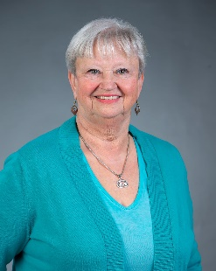 Barbara J. Ochester, EdD candidate, MSN BSN, RN, began her professional career as a Registered Nurse over 48 years ago. Building a foundation in bedside nursing in the Medical/Surgical, Intensive Care, and /Emergency Departments, she continues active clinical practice doing cannabis counseling, wellness clinics, and immunization nursing. Barbara assumed leadership roles in each of the units where she worked.
Today, Barbara teaches Community Health I and II, Nursing Leadership, and Health Assessment at the university level in addition to her duties as a Clinical Counselor for patients seeking help in determining which cannabis products would be best for them. Each cannabis patient deserves the opportunity to meet with an educator to determine the correct medicine for their symptoms or diseases. Barbara has just completed her doctoral classwork and is ready to dive into the research phase of her degree in Health Administration and Leadership. She will focus on cannabis research and the lived experiences of patients. Education remains a top priority for her, teaching medical professionals, patients, and caregivers, what is available, what works, how to access, and how to use cannabis and cannabinoid products.
Barbara has just accepted a position at Pacific College of Health and Sciences teaching in the medical cannabis track. Her goal is to contribute to the body of knowledge and build on what we know about using cannabis as an alternative/adjunct to traditional treatments and medications. Many patients are treating their chronic pain with opioids and are desperate to discontinue them. The introduction of cannabis into their regimen has been highly successful for these patients.
Prior to commencing her nursing career, she used her undergraduate education at Cornell University, followed by her first nursing program in Dryden, NY. Several years later, Barbara received her bachelor’s in nursing and master’s in public health nursing at La Salle University in Philadelphia. The transition to cannabis nursing was a natural progression in providing care and education for those who have exhausted traditional pharmaceuticals or are at the end of their traditional therapeutics rope and the side effects and reactions from their medications that are no longer tenable.
Barbara spends her time at home in Philadelphia, where she resides with her husband and two dogs. To her delight, her children and grandchildren are close, and she can spend time with them.

