When:
SATURDAY, APRIL 9, 2022
Where:
Blue Ridge Community College (Building G)
Weyers Cave, VA (Houff Student Center) Exit 235

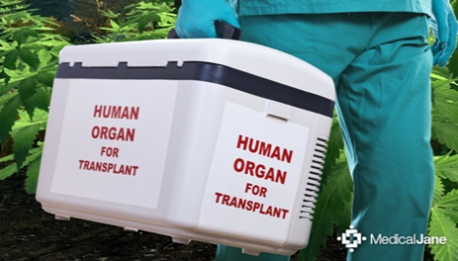
VASMA.org
A face mask must be worn inside the school at all times by school mandate.
No food or drink is allowed in the meeting room.
Dining area outside of the room.

Agenda:
Friday
7:00 – 9:00 p.m. Executive Board Meeting- Zoom

Saturday:

7:30 – 8:00 Welcome & Announcements/Registration

8:00 – 9:00 - United Network for Organ Sharing

9:00 – 10:00 Precertification- Ashleigh Jackson

10:00 –11:00 Time with Vendors/break

11:00 - 12:00 Post Transplant Coordination- Shawn Floyd, NP

12:00 – 1:30 Lunch/installation of officers/ AAMA Representative

1:30 – 2:30 Heather Brushwein PsyD, Assistant Professor of Psychiatry &
Neurobehavioral Sciences

2:30 - 3:30 A Transplant Caregiver Perspective- Stephanie Davis, CMA (AAMA)

3:30 – 5:00 Annual Meeting – open to all members- please bring your membership card

Five CEUs have been approved by AAMA.

Vendor: Scentsy- please support vendors as they give up their time to bring you an opportunity to buy gifts for yourself and others.

Our President’s charity is Autism Speaks- we will take donations at the meeting.
https://www.autismspeaks.org/provider/autism-society-central-virginia

The Conference Committee reserves the right to change the speakers, schedule, or topics. Photos may be taken during conference and may be posted on the web site or Face Book.

Conference Financial Information:

Member Registration: $50.00
Non-Member Registration: $60.00
Student Registration: $15.00

All funds should be sent to Ms. Frasier listed below.

Financial Restitution covers:
CEUs,
Breakfast: Danish, muffins and buns
Lunch: Box Lunch
Bring your own beverage for breakfast.

Accommodations are Available:
The Holiday Inn Staunton Conference Center
152 Fairway Lane, Staunton, Va.
(540)-248-6020 office

Availability:
Providing 15 double rooms at the rate of $139.00 per night.
Reserve early to get that rate.
Reservations must be made by March 9, 2022.

Directions:
It is right off of interstate 81 North.
It is exit 225, turn left and the entrance will be on your right shortly after getting on the road.

Click the link to reserve a room VSMA @ Holiday Inn Staunton Conference Center
_____________________________________________________________________________
______________________________________________________________________________

Medical Assistant Name and Credential

Member Non-Member Student
Name: _______________________________________________________________
Credential: ___________________________________________________________
Phone Number for contact if needed _____________________________________
Mail registration and check to:
Tanisha Farissier, CMA (AAMA):
1724 Featherstone Drive, Midlothian, VA 23113
or
Pay Pal by going to vasmainfo@gmail.com

For questions email Deb Benson at donaldbenson07@comcast.net
No refunds after March 20th and only in case of emergency.

