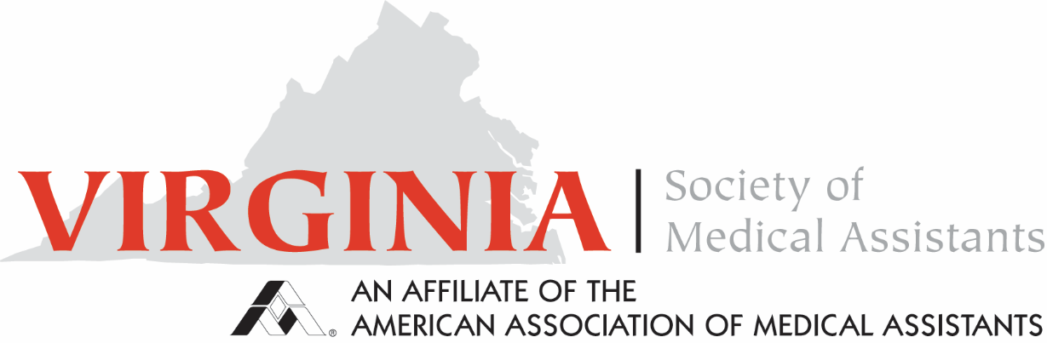

Minutes for Executive Board Meeting August 18, 2024

Online via Teams

Called to order at 2:00 pm by President Deb Benson

No minutes from the previous meeting were provided for approval.

**Officers Reports:**

Treasurer Report- Nothing to Report. No questions

President Report- Board of Trustee Highlights:

CEUs—Medical Assisting Today will offer an article worth 2.5 CEUs and another worth 1 CEU. Starting with the September/October issue, there will be a $20 fee for both.

A request for volunteers for the National 2025 conference committee was sent by email

Barbara developed a letter for non-member CMAS to rejoin the chapter.

Vice President - Will be a member of the review board for the medical terminology course for community colleges, organized by the Virginia Department of Education.

Has attempted to partner with OrthoVirginia for broader access to their monthly CEU offerings. The request was denied as the OV could not verify a roster of attendees. OrthoVirginia is willing to conduct CEU sessions independently for the VSMA. Benson inquired if there would be an ability to charge for OV CEU offerings. CEU sessions would be free for state members as OV does not charge the public. Charging a fee for out-of-state members is being considered. Ability to obtain free CEUs will be promoted as perk of joining state chapter

Immediate Past President- Nothing to Report

Parliamentarian- No report

Membership- No report

Certification- No report. Sending welcome letters to all new CMAs. Virginia informed the AAMA membership that it has a letter for new CMAs and non-members, which emphasizes the benefits of membership.

Pubic Policy- US Congress and legislature are in hiatus. Nothing on the horizon affecting the right to practice

Social Media- Pages are updated regularly. VSMA page is growing in followers. Conversion to membership is unknown at this time. Sharaon states a Google search of Chapter points to old document from 2014. Does not direct to webpage. Removal of document will assist in search results.

**Standing Committee Reports:**

Bylaws: There is no report, but a document was sent to committee members for review by the end of the month. Changes will be incorporated and updated. We will reassess at a future meeting. The AAMA Bylaw committee begins this Fall. A volunteer form was sent with a request for volunteers for the national committee.

Conference Committee- Final report from April conference will be sent to the Board. Accomodations for 2025 conference State conference has been identified. Hotel is near Tidewater Community College with improves conference accessibility.

New Business:

1. Zoom
   1. Aspen Zoom will no longer be available. Nina volunteered use of personal Zoom account for meetings. Amanda expressed that VSMA should have its own access. All board members would have access for committee meeting usage. Deb Houston agreed. Rejected use of Microsoft Teams due to connectivity issues. Zoom meetings could be recorded to assist with the recording of minutes. Amanda will research reduced cost accounts for non-profit organizations. Will follow up by email for decision and vote.
2. National Conference
   1. Nina is scheduled for an upcoming update meeting. Informed past chapter presidents may be used to fill openings for CEU sessions at national conference
   2. Hosing state chapter will present reveal of 2025 conference during the ‘24 conference party. Suggested developing a brochure of “Things to Do” in the area for ’25 Conference. Video showcasing “Sites to See” presented in Michigan during ’24 conference to stir excitement. Research possible discount parking near hotel.
   3. 5 will attend Michigan Conference
3. VSMA 25 Conference- 2-3 CEU offering for single day conference. Suggested Waynesboro/Salem area for conference. All attending were in agreement. Best Western Conference Center off I-64 would be the best location
4. Membership- Sharon proposes a VSMA introduction letter to be sent to MA programs to solicit new members. There are 34 programs that could be contacted. Board members could offer to be guest speakers on the MA career post-graduation to establish relationships with programs. Suggested possibly VSMA sponsorship for new members. Suggested five-for-five promotion: Pay $5 for conference registration. You get five members to attend, or if five students attend, have a drawing for a 1-year membership. Suggested are ways to increase exposure and increase involvement. The membership committee will decide on future direction. Membership budget funds may be used for sponsorship.
5. Nominating- Nothing to report. Will post Facebook and Website information
6. Announcements:
   1. Reel Talk with Medical Assistants videos will premier next week.
   2. Nina writing LPN textbook featuring LPNs. If the committee knows of LPNs who would like to be feature, please send information to Nina at [ninarn@yahoo.com](mailto:ninarn@yahoo.com)
   3. Sharon Smith updated email address is [SmithS@associnps.com](mailto:SmithS@associnps.com)
   4. Virginia has completed campaign items for ’24 National Conference

Adjourned 3:14 pm

Respectfully Submitted

Terry Harris, MBA, CMA (AAMA)