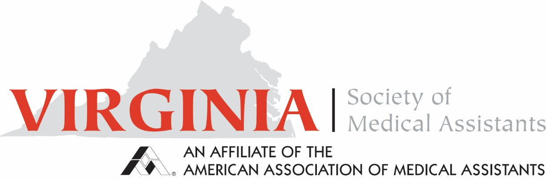
Minutes for Annual Business Meeting April 5, 2025

Call to Order
The meeting was called to order at 1:20 PM by President Deb Benson.
Officer Reports
Officer reports were distributed electronically prior to the meeting.
Treasurer: Debby Houston
President: Deb Benson
Vice President: Amanda M. Harris
Immediate Past President: Nina Beaman
Parliamentarian: Mary Schuknecht
Committee Reports
Membership
Sharon Watson reported ongoing efforts to increase student engagement, including outreach to educational institutions. Additional initiatives are planned to encourage student attendance at VSMA sessions.
Certification
Report provided by Debby Houston.
Public Policy
No report. (Nina Beaman)
Social Media
The Facebook page remains active, sharing content from AAMA. Virginia shares posts from AAMA and a post linking to a newly redesigned website (Amanda M. Harris) that automatically loads Facebook posts.
Standing Committee Reports
Bylaws Committee
A written report was distributed prior to the meeting with proposed changes. Editorial revisions were completed prior to the meeting. Proposed amendments included the following:
Article 7, Section 5: Amend to state the term of the Treasurer shall be two (2) years. Rationale: Annual Treasurer changes create banking difficulties and a two-year term allows continuity and proficiency in the role.
Article 8, Section 2: Amend to remove Vice President responsibility for obtaining continuing education units (CEUs) for the VSMA Fall Education Seminar and VSMA Annual Spring Conference. Rationale: A new standing committee will assume this responsibility (Continuing Education Committee).
Article 8, Section 3: Amend Secretary duties by changing review responsibility from an edit committee to the Executive Board, reflecting that the Executive Board reviews minutes for accuracy prior to posting to the website.
Article 9, Section 5: Amend to refer to Appendix A for delegate and alternate delegate guidelines and responsibilities, due to the comprehensive list of obligations before and during the AAMA Annual Conference.
Article 10, Section 6: Amend Executive Board meeting requirement to four (4) meetings annually. The first three meetings are at the discretion of the President, with dates set at least thirty (30) days prior to the meeting unless deemed an emergency meeting. Rationale: Provides flexibility and avoids locking meetings to certain months or seasons.
Article 14, Section 2: Clarify committee composition as chairperson and additional members as needed to propose editorial changes to VSMA bylaws for the State Society; such editorial changes do not require approval by the Society’s legislative body.
Article 14, Section 10 (New): Add a Continuing Education Committee consisting of chairperson, program planner, and additional members as needed. Responsibilities include developing two (2) virtual CEUs, arranging speakers, obtaining CEUs from AAMA, and submitting information to the Social Media Chairperson and Webmaster for member announcements. The committee will assist annual conference chairperson(s) and submit required documents to the program planner forty-five (45) days prior to conference to allow for AAMA approval.
Article 14, Section 2 (Seminar): Remove the current seminar subsection, as seminar responsibilities fall under the Continuing Education Committee.
Community Service: Revise responsibilities so the Community Service Chairperson works with the Social Media Chairperson and Webmaster to advertise via Facebook and the Society website. Chairperson shall submit to AAMA for the annual Excel Award. Rationale: A committee will determine the project; responsibilities should not default to the President.
Standing Rules: Motion to remove all standing rules except Standing Rule #5. Rationale: Standing rules are unnecessary if approved content is incorporated into the bylaws.
Discussion: Nina Beaman noted the intent to tighten and clarify which expenses are paid versus not paid, aligning them with current employer culture.
Action: No opposition was noted. The proposed bylaw changes were adopted by unanimous consent.
Committees
Committee members were appointed. A separate roster sheet lists appointed members. Action: Committee appointments were approved.
Reports of Special Committees / Projects
Current Conference
There was hope for increased attendance; however, scheduling during spring break created challenges, including difficulty securing speakers. The topics presented contained excellent information.
Future Conference
Possible future location includes Tidewater Community College; room availability is not expected to be confirmed until later in the year. Alternative sites near multiple hotels are being considered.
New Business
1. Community Activities (Annual Project)
Neighbor Bridge requested hygiene products to be donated at the meeting; additional distribution options discussed included public locations such as libraries.
Valley Mission identified a need for first aid supplies.
A “Blessing Jar” was established for cash donations.
These activities were identified as the current year’s community service project.
2. Two-Year Strategic Plan
A two-year strategic plan was included in the packet distributed prior to the meeting. Action: No objection was raised; the strategic plan was accepted.
3. Election of Officers
The vote on officers was completed. (Election results are recorded separately.)
Announcements
AAMA Conference
Attendees will receive lanyards; a scanning process will be used as individuals enter the room.
A volunteer sign-up sheet circulated for members to assist with scanning attendees into rooms.
The website includes sign-up links for scanning badges, serving as timekeeper, backup speaker, and Ways and Means teller.
Ways and Means will have Cash App and Venmo accounts available.
Ways and Means Fundraising
Fundraising items include DIY clipboards and clipboards made by Bryant & Stratton College, as well as other one-of-a-kind items.
Raffle tickets will be sold for a “Weird Virginia” book.
There is a need for backup speakers at the conference, with monetary compensation.
House of Delegates
The House of Delegates contracted with the Native American Warrior Women (in regalia) to march in before the meeting.
Member Updates
Nina Beaman reported new employment with Mary Baldwin College in Staunton, VA.
Midkiff announced an engagement.
Adjournment
The meeting was adjourned at 2:17 PM.

Respectfully Submitted,
Autumn “Cheyenne” Testerman, CMA (AAMA)

