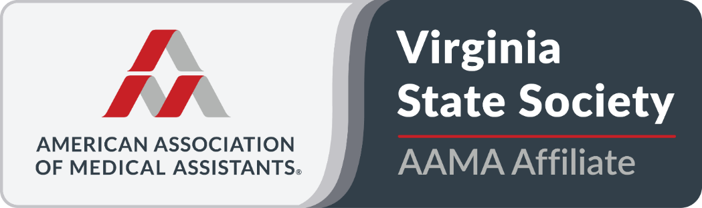
Delegate’s Report
AAMA Conference 2025
Alexandria, Virginia
I arrived early on Thursday afternoon to assist with setting up the Ways and Means table. With the assistance of Terry Harris and Deb Benson, all remaining merchandise was organized and displayed for sale. By the conclusion of the first day, approximately 35% of the merchandise had been sold.
On Friday morning, I reopened the Ways and Means table and conducted sales for approximately 30 minutes following breakfast. The table was then covered while I attended the first conference session. After the first speaker, I returned to resume sales operations. I later left the table in the capable hands of Terry Harris and Cheyenne, while I presented during the second conference session on professionalism and professional development for medical assistants. For the remainder of the day, I managed the Ways and Means table, which proved to be very popular as it was the only active sales table.
Friday evening, I closed the table and prepared for the themed awards banquet. By the end of the second day, the Ways and Means table had fully recouped the initial investment and had begun generating a profit.
On Saturday morning, I resumed sales operations at the Ways and Means table after breakfast. I later delegated responsibilities to Cheyenne, Debby Houston, and Deb Benson while I attended the House of Delegates session with Terry Harris, Vice President. This session was interrupted by a fire alarm evacuation; however, approximately one hour later, the House reconvened. After the session concluded, I returned to the Ways and Means table and continued sales until closing. I then prepared for the third and final House of Delegates session.
By the end of Saturday, inventory was limited, though remaining items continued to sell through creative marketing efforts by all involved. At this point, total revenue exceeded expenses by approximately 50%.
On Sunday morning, I prepared for my second speaking engagement on the topic of artificial intelligence and the medical assistant. Throughout the day, I continued to manage the Ways and Means table between sessions alongside Terry Harris and Cheyenne Testament, with additional assistance from new Membership Committee members Michaela Monroe and Ciani Jackson. I did not attend CEU sessions that day, as my priority remained supporting Ways and Means sales.
At the end of the day, we dismantled the table and packed remaining inventory. Some items will be sold to medical assisting students, and others will be offered for sale at the Spring Conference in Virginia Beach in April 2026. That evening, I met with Debby Houston to transfer the collected cash proceeds and a donation check from a fellow AAMA member to the VSMA. We received numerous compliments regarding the merchandise selection. The only noted suggestion was the absence of a Virginia state pin, which will be considered for future events.
I attended the President’s Banquet that evening and was seated with Joyce, Mary, May, and Sharon. Following the banquet, I returned to my room and concluded the day.
On Monday, I attended a two-hour session titled Medical Marijuana, introduced Sharon Smith, and checked in with Mary. Both performed exceptionally well. I checked out about 11 AM and headed back to Chesterfield, to be in a Television Advertisement promoting Medical Assisting.

Amanda M. Harris, EdD, MHA, CMA (AAMA)
VSMA President, 2025–2026

