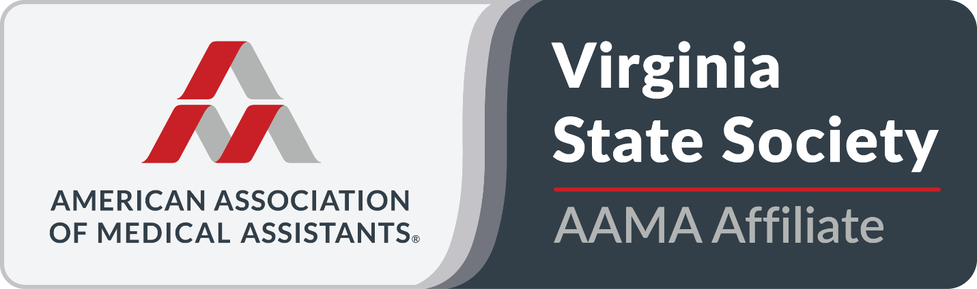
Executive Board Meeting
January 19, 2026
President Report

- I lead that last meeting held on 11/11/2025.

- I joined the AAMA Editorial Advisory 2025-2026. My first article review deadline is 01/20/2026. The next is 03/15/2026.

- I created marketing materials for the VSMA and contests. This includes a

- In honor of MAR week I drove around to over a dozen sites in the Midlothian area and gave out business cards that I made along with goodies, such as candy, cookies and pastries to medical offices.

- I Read and responded to no less than 30 emails from the AAMA, VSMA members and Committees and employers between 11/11/2025 and 01/18/2026.

6a. I continue to maintain vasma.org. All applications and certificates are up to date. This includes the payment system of Stripe that captures all credit card payments and direct deposits them into our checking account.
6b. I spent a considerable amount of time looking at ways to improve our site. Per an email I received from Sharon Smith, the format of the main page is not showing our facebook details. This is due to the shared content from the AAMA not posting to our website. This is a work in progress.
6c. In order to continue to keep our website up to date for the Spring Conference, I moved registration to the main landing page. I build additional pages such as the Sponsorship page and vendor pages. I utilized the page setup that was provided in a word document from Virginia Thomas and Sharon Smith the 2026 Conference Committee Chairs. (Thank you ladies.)

- I continue to maintain the VSMA LinkedIn account with updates from the VSMA and the AAMA. The Spring Conference is an Event open to be shared. https://www.linkedin.com/events/7418817213048090624/?viewAsMember=true

- Per and email send to me by Deb Benson we have now partnered with VCU to offer CEU’s for our membership at their VCU Health of Women’s Conference on 05/29/2026. Once I get the remaining data from my contact at VCU, Nick will complete the CEU approvals. I will post our involvement at that time for our membership.

- I continue to check our emails daily. The original address of vasmainfo@gmail is still active as there are some sites that use this.

- Our new email address is va-sma@outlook.com This change should eliminate our communications with members from going to spam folders.

- I have been working with Microsoft to get the VSMA registered as a Non-Profit. The purpose is to obtain free resources for the VSMA in reference to communication and continue to promote and update the VSMA professionally. This is ongoing.

- I continue my efforts to help expand the outreach and awareness for the Medical Assisting Profession with my outreach to the different MA schools in Virgina and by opening the VSMA Apparel Store in November-December 2025. The store will reopen the entire month of March for Spring orders/ designs and include membership led design details. The new launch will include shirts featuring Medical Assistant and VSMA have been popular as well as Student designs. The newest designs offer one for Retired Medical Assistant as well.

Amanda M. Harris Ed. D, MHA, AAS-MA, CMA (AAMA)
VSMA President 2025-2026

